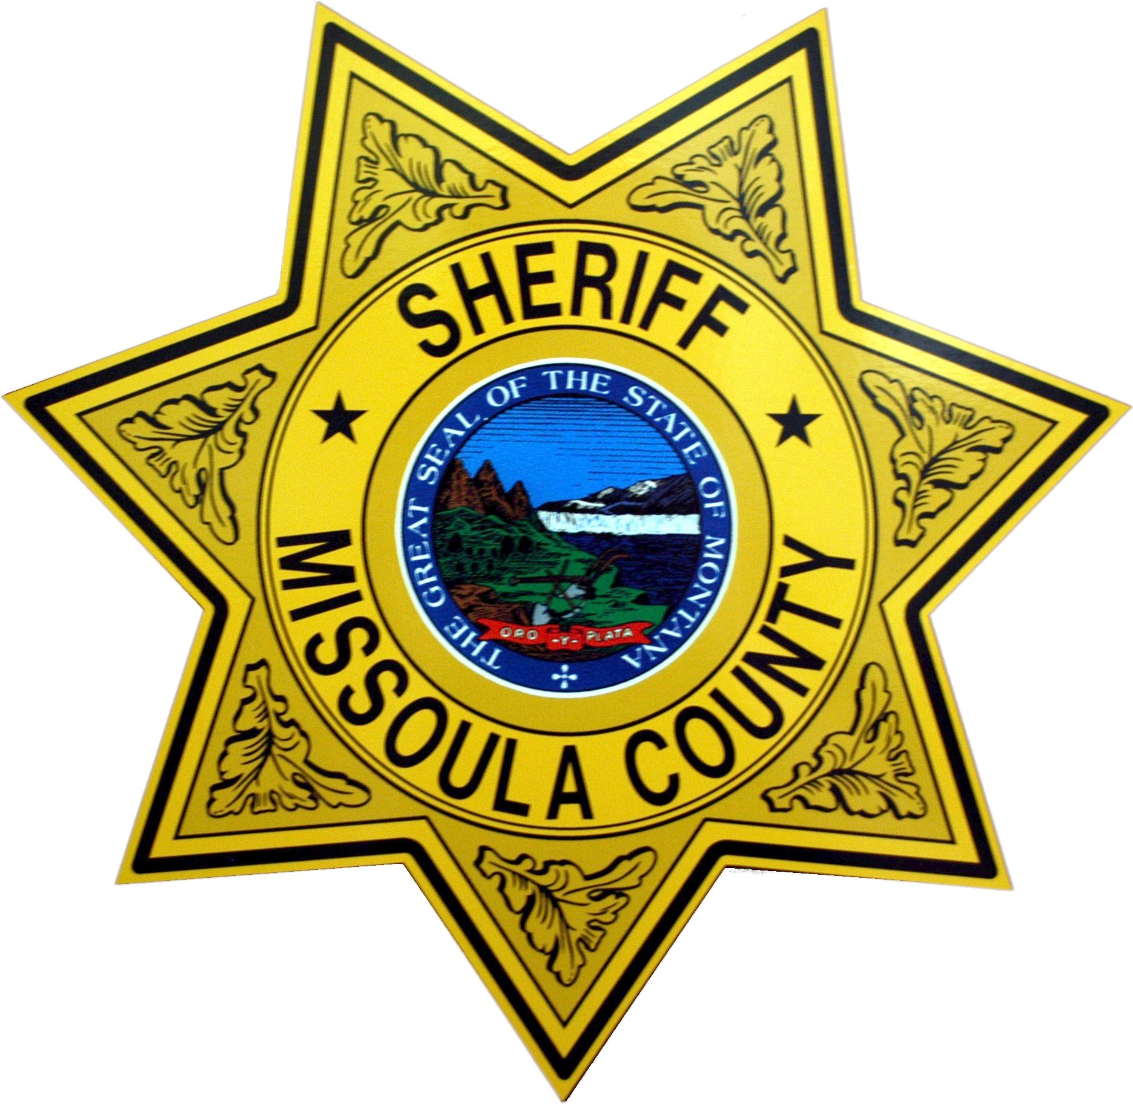 | MISSOULA COUNTY SHERIFF’S OFFICE  RETIRED LAW ENFORCEMENT OFFICER WAIVER AND RELEASE OF LIABILITY

LAST NAME: __________________________________________________________________

FIRST NAME: _______________________________MIDDLE _________________________

DATE OF BIRTH: ______________________________________________________________

HOME ADDRESS: _____________________________________________________________

CITY: _______________________________STATE: ____________ZIP CODE: ___________

PHONE: ______________________________________________________________________

EMAIL: ______________________________________________________________________

DATE OF INTIAL EMPLOYMENT:_______________________________________________

DATE OF RETIREMENT WITH: _________________________________________________

WAIVER AND RELEASE OF LIABILITY

In consideration of the County of Missoula, Located in the State of Montana and the Missoula County Sheriff’s Office, permitting me to qualify to carry a concealed firearm under the Law Enforcement Officers Safety Act of 2004, 18 U.S.C. 926 C, I the undersigned ________________________________ hereby acknowledge, understand and agree that:

- I recognize and assume the risks and dangers inherent in firearm qualification, both known and unknown, even if arising from the negligence of the Missoula County Sheriff’s Office, (including their respective officers, agents or employees).

- I understand that by signing this Waiver Form, I am releasing and holding harmless the Missoula County Sheriff’s Office (including their respective officers, agents or employees) from any and all liability, including its/their own negligence, for any personal injury, death or damage that arises out of my participation in the firearm qualification course or from my subsequent carrying or use of the firearm for which I am qualifying to carry concealed under the provisions of the Law Enforcement Officers Safety Act of 2004, 18 U.S.C. 926 C.
- I agree to waive and release the Missoula County Sheriff, the Missoula County Sheriff’s Office, the Missoula County Government, the Missoula County Commissioners, and each of their directors, officers, agents, and employees, (collectively “the County”) from liability for all claims for damage or loss to my person or property which may be caused by any act or failure to act on the part of the County.
- I agree that if any claim is commenced against the County based on acts that I take or fail to take, I will defend, indemnify, and save the County harmless from any and all claims or causes of action, injuries, or damages.
- I acknowledge, understand, and assume all risks related to the police training, qualification, and exercises. I understand that these activities may present risk of serious danger to my person (including death) and to my property. These risks and dangers may be caused by my negligence or the negligence of others including other participants, trainers, supervisors and county officials or employees. I further acknowledge that there may be risks and dangers not known to the County or not reasonably foreseeable at this time. I acknowledge, understand, and agree that all of the risks and dangers (regardless of whether specifically described in this agreement or not) however caused are included within this waiver of liability release and indemnification agreement. I waive any and all specific notice of such risks or potentially dangerous conditions.
- I acknowledge, understand and assume the risk arising from the training and qualification sessions and exercise as well as the conditions of the training areas and related premises and I acknowledge and understand that included within the scope of this waiver and release are any causes of action arising from the maintenance, inspection, supervision or control of said areas, or the failure to maintain, inspect, supervise or control said area and for failure to warn of dangerous conditions existing at the training area (known or unknown).
- I have been advised that the Sheriff’s Office intends to record, by videotape or other methods, all, or part of the training and qualification sessions and/or exercises in which I will participate or which I may observe. I consent to such recording and understand that the recording will remain at all times the property of the office of the Sheriff.
- I have been advised the Missoula County Sheriff’s Office intends to conduct a background search, including but not limited to, the National Crime Information Center (NCIC) database and any other background investigation as determined necessary by the Missoula County Sheriff’s Office in its discretion.
- I understand and agree that the parts of this Agreement are severable and that should any part of this agreement be declared unenforceable the remainder of this agreement shall nevertheless remain in effect and enforceable to the full extent allowed by law. I understand that I have the right to consult an attorney of my choice, at my own expense, before I sign this agreement.
- I agree that this Agreement is binding on my agents, heirs and assigns.
- I certify that 1am 18 years of age, or older, and that I am competent to make this Agreement.
- I acknowledge that I have been provided with this Agreement at least 5 days before start of the training and qualification sessions and exercise that I have not relied upon any contrary representations expressed or implied of any matter covered by or in any way related to this Agreement.

I acknowledge that I have read and that I understand all of the provisions in this Waiver and release of Liability.

_____________________________________________ ____________________
Signature / Date

NOTARY REQUIRED FOR APPLICANT’S SIGNATURE
Subscribed and sworn to before me:
Notary Public_________________________________
This_______________Day of _____________20_____
My Commission Expires________________________ (seal)

